My computer screen is faint and too dark at full brightness

1. [Uninstall and reinstall the display driver](https://windowsreport.com/computer-screen-dimming-issue/#1)
2. [Disable adaptive brightness](https://windowsreport.com/computer-screen-dimming-issue/#2)
3. [Roll back the display driver](https://windowsreport.com/computer-screen-dimming-issue/#4)
4. [Update the BIOS](https://windowsreport.com/computer-screen-dimming-issue/#5)
5. [Perform a hard reset](https://windowsreport.com/computer-screen-dimming-issue/#6)
6. [Check the display before Windows opens](https://windowsreport.com/computer-screen-dimming-issue/#7)

### 1. Uninstall and reinstall the display driver

* Right click **Start**
* Select [**Device Manager**](https://windowsreport.com/device-manager/)

[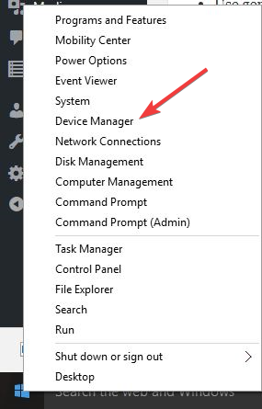](https://cdn.windowsreport.com/wp-content/uploads/2018/02/right-click-start-device-manager-3.png)

* Click **Display driver/adapter**

[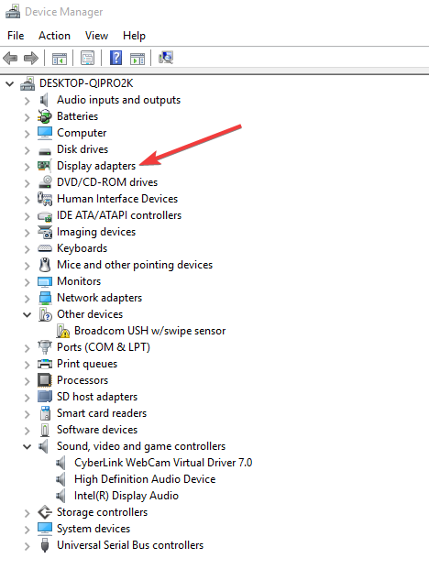](https://cdn.windowsreport.com/wp-content/uploads/2018/02/display-adapters-1.png)

* Select the name of your display driver e.g. NVidia
* Click **Uninstall**
* Confirm that you wish to continue with the uninstall
* Once driver files have uninstalled, restart your computer to automatically install the generic display driver

### 2. Disable adaptive brightness

* Click Start and type **Calibrate display color** in the search box
* Click on **Calibrate display color** from the search results

[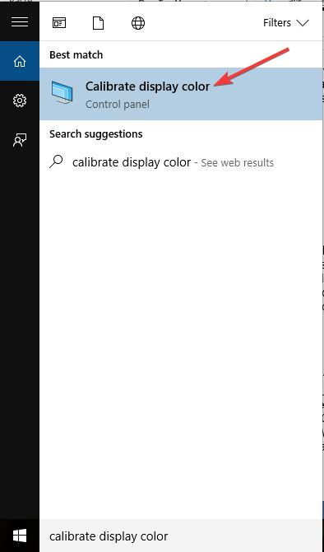](https://cdn.windowsreport.com/wp-content/uploads/2018/02/calibrate-display-color.jpg)

Ad

* On **Display Color Calibration**, click **Next**to open the **Set basic color settings** screen, then click Next again
* A new window “**How to adjust gamma**” will open, click **Next.  Adjust gamma** window opens.
* Set the color settings to your preference.
* Sliding up increases brightness, while sliding down decreases it.
* Press **next** when done.

[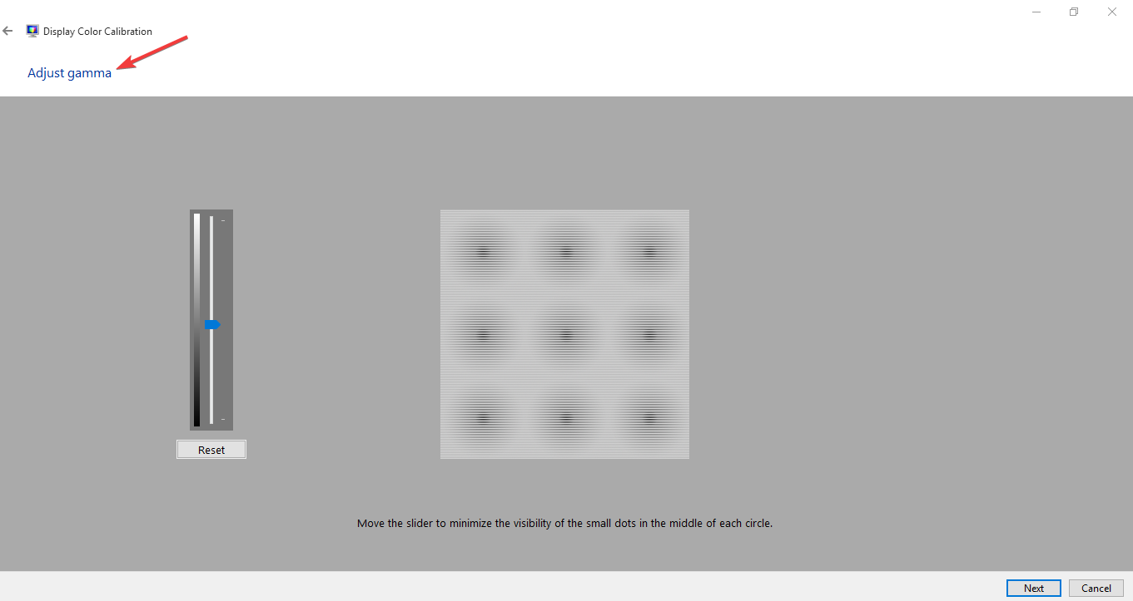](https://cdn.windowsreport.com/wp-content/uploads/2018/02/adjust-gamma.png)

* The **Find the brightness and contrast controls for your display** window opens.

[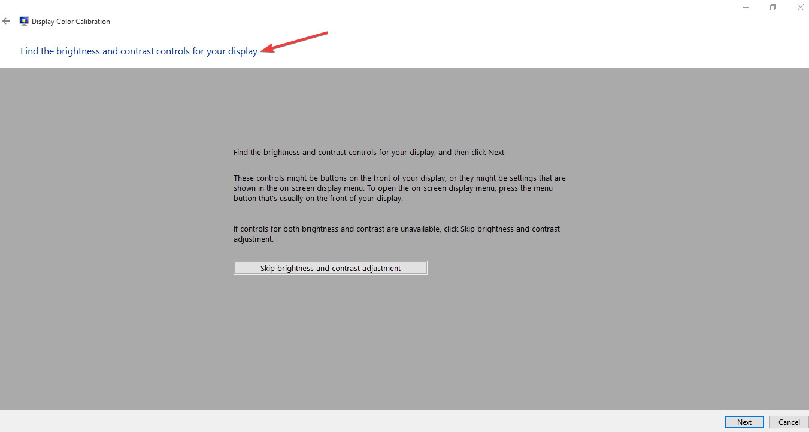](https://cdn.windowsreport.com/wp-content/uploads/2018/02/find-the-brightness-and-contrast-controls.png)

* Click **Skip brightness and contrast adjustment**if you don’t want to adjust brightness and contrast.

[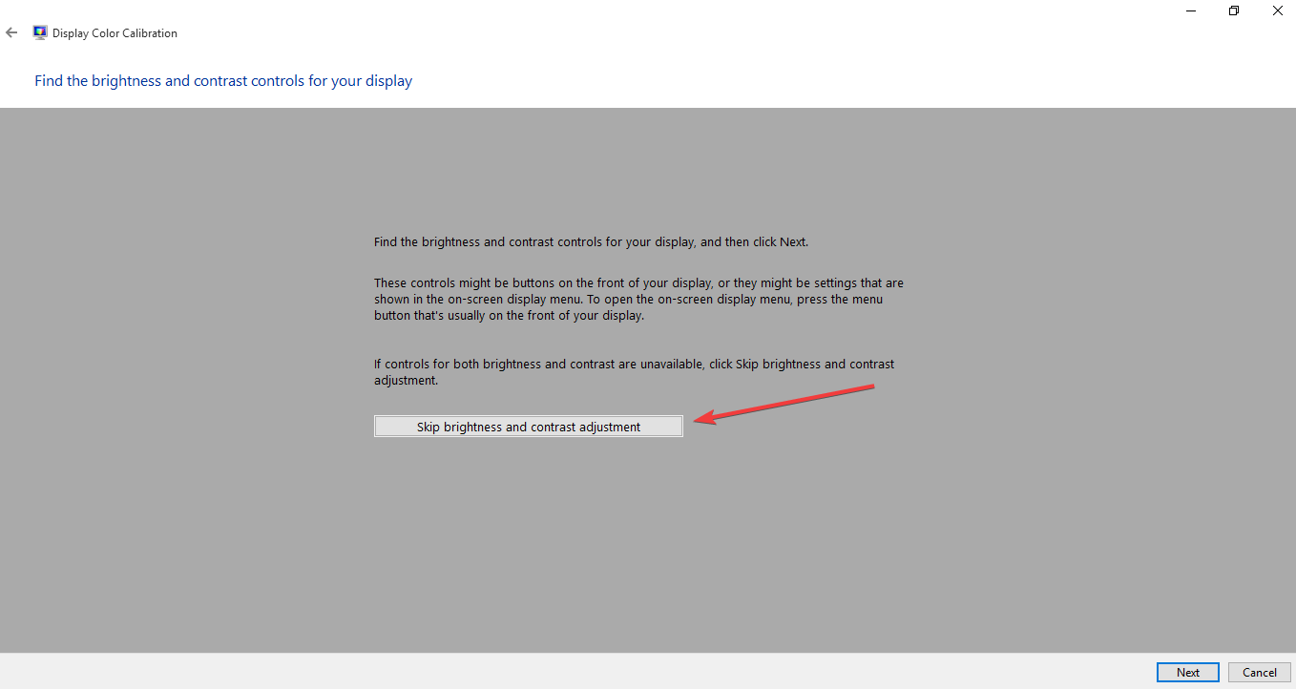](https://cdn.windowsreport.com/wp-content/uploads/2018/02/skip-brightness-and-contrast-adjustment-1.png)

* If you want to adjust brightness and contrast, click **Next** to open **How to adjust brightness** window, then click next again.

[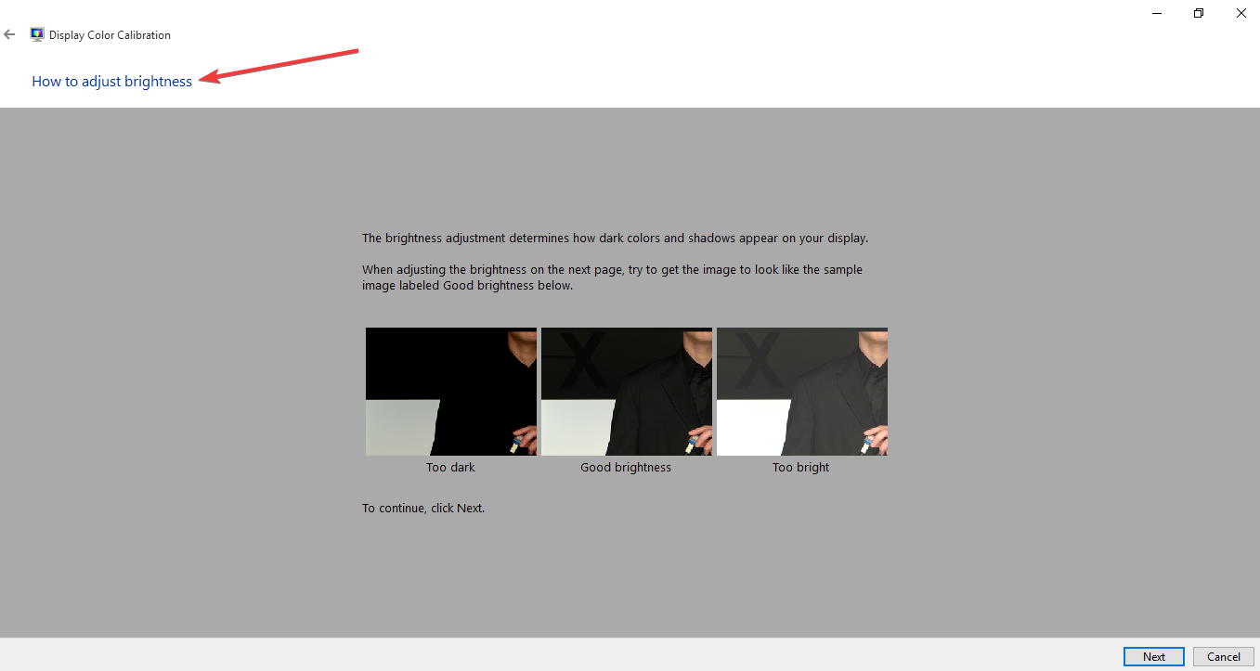](https://cdn.windowsreport.com/wp-content/uploads/2018/02/how-to-adjust-brightness.png)

* Use your display controls to adjust the brightness until you can see clearly, then click **Next**twice and adjust your contrast settings.
* Click **Next** again to open the **How to adjust color balance window**, and click **Next** to proceed.
* A new window called **Adjust color balance** will open so you can slide to adjust primary colors like red, blue or green accordingly. Click **Next** to proceed.

[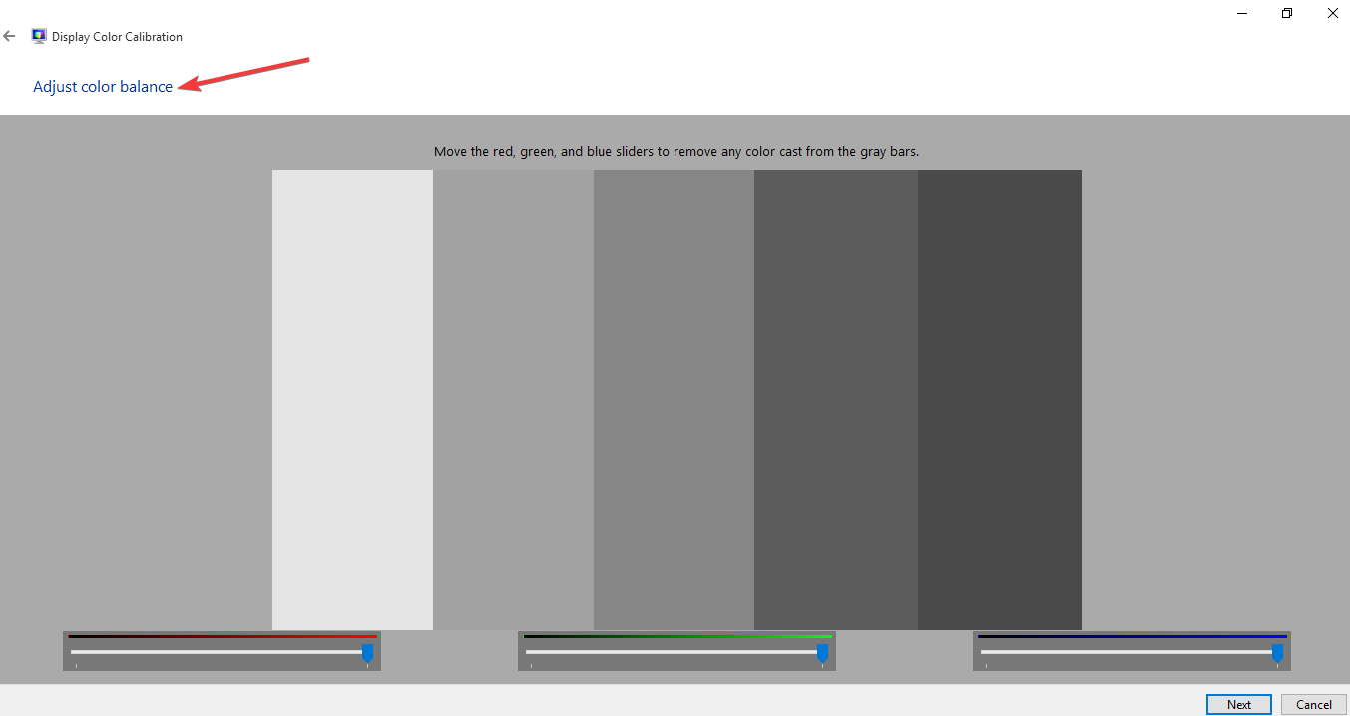](https://cdn.windowsreport.com/wp-content/uploads/2018/02/adjust-color-balance.png)

* Click **Finish** to save your settings

### **Roll back the display driver**

* Right click **Start**
* Select **Device Manager**
* Select **Display adapters** and click to expand the list then choose the NVidia card.

[](https://cdn.windowsreport.com/wp-content/uploads/2018/02/display-adapters-1.png)

* Right click the on the card, and then select **Properties**.
* In Properties, select the **Driver**tab

[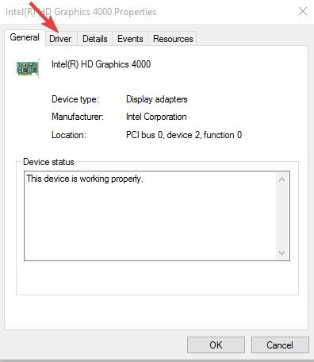](https://cdn.windowsreport.com/wp-content/uploads/2018/02/driver-tab-display-adapter..png)

* Select **Roll Back Driver**, then follow the prompts

### **Update the BIOS**

* Find your current BIOS version number by clicking Start then typing **msinfo32.exe**in the search box. Click **msinfo32.exe** from the list of results

[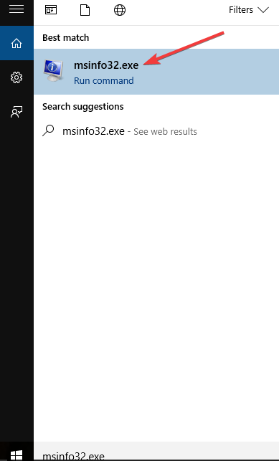](https://cdn.windowsreport.com/wp-content/uploads/2018/02/msinfo32exe-1.png)

* In the **System Information** window, look for **BIOS Version/Date** (your current BIOS version) and write it down on the paper

[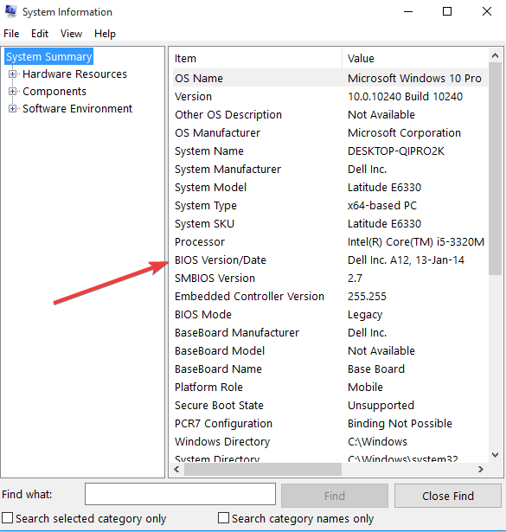](https://cdn.windowsreport.com/wp-content/uploads/2018/02/BIOS-version.png)

* Click Start then type **exe** in the search box.
* Click **msinfo32.exe** from the list of results
* In the **System Information** window, look for **Processor entry** and write it down on the paper.
* Ensure that the BIOS you are about to install is meant for use with your computer’s specific processor.

[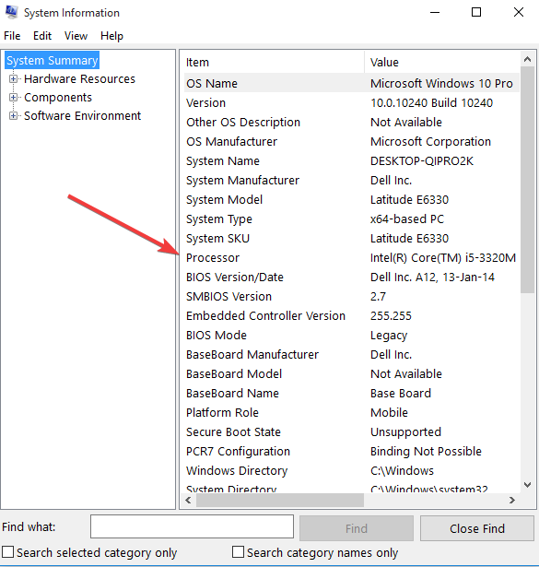](https://cdn.windowsreport.com/wp-content/uploads/2018/02/Processor-type-1.png)

* Find and download BIOS updates by going to your computer manufacturer’s website and find the product page for your computer’s model. Select the OS and click Submit. If a BIOS category is listed, select BIOS then choose the correct one for your processor and follow the screen prompts

**Note:** make sure to read the overview and system requirements to confirm the BIOS update is for your computer, then click Download and save it to your desired location. Don’t select Run BIOS update over the network.

* Install the BIOS update, which will take a few minutes during which time the computer may beep or display goes blank, cooling fans will turn on and off, and the power button will flash – this is normal and expected. Do NOT shut down or restart until the update is complete.
* Close any open programs prior and disable your antivirus (enable after installation).
* Find the BIOS file and double-click on it to start installation then follow on-screen prompts.
* Wait for the installation to complete and restart your computer.

There are cases where an outdated BIOS causes your computer screen is faint, or the screen brightness is too low even at 100% and/or the laptop screen is too dark at full brightness.

[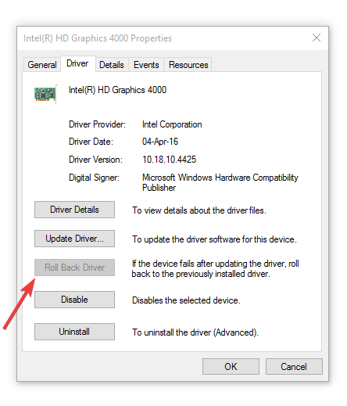](https://cdn.windowsreport.com/wp-content/uploads/2018/02/roll-back-driver.-1.png)

**Note:** If the roll back button is greyed out or unavailable, that means there’s no driver to roll back to.  Visit your computer manufacturer’s website to download the latest driver.

### **Perform a hard reset**

For [removable battery computer](https://windowsreport.com/best-browsers-battery-life/), switch off the computer and remove any plugged devices, disconnecting all external connected peripherals, and then unplug the power adapter from the computer.

* Remove the battery from its compartment, and then press and hold the power button on your computer for about 15 seconds to drain any residual electrical charge from its capacitors.
* Insert the battery and power adapter back to the computer but don’t connect any other devices just yet
* Press the Power button to turn on your computer. You’ll see the startup menu opening, so use the arrow keys to select **Start Windows Normally** and press Enter
* You can now reconnect the devices one at a time, and you’re good to go. Remember to run Windows Update and update all device drivers.

For a computer with a sealed or non-removable battery, don’t try to remove it as this can void your warranty. Do the following instead:

* Turn off the computer and remove any plugged devices or peripherals, and unplug the power adapter from the computer.
* Most [laptops](https://windowsreport.com/windows-hello-laptops/) can be reset by pressing and holding the Power button for 15 seconds. So do this, then plug back the power adapter but not any other devices.
* Press the Power button and start your computer, then select **Start Windows Normally** and press Enter
* Reconnect other devices and peripherals, one at a time, and run Windows Update as well as updating all device drivers after the reset.